# Introduction

The first group assignment for the Introduction to Information Systems, our module leader, Mr Hrishav Tandukar, assigned us to create an e-commerce website for a business that sells different watches. There were some obstacles to overcome when creating this e-commerce website because all the members at group were new and unfamiliar with the idea of creating a complete website using HTML, CSS and JavaScript. However, we successfully completed the project in the end.

For this project, we are going to making an e-commerce website using other six different webpages. Firstly, the users are introduced to smart watches while they click the website in the index page, i.e. home page. Along with that they can purchase various smart watches according to their needs. They can also use customer care and contact us through about us section. Users can get information about the company whose watches are listed at the e-commerce website in the blog section.

# Discussion and Analysis

In order to have a clear knowledge of what should and shouldn’t be done for your website, we must create a prototype before we can create a properly operating website. Balsamiq is used to create a wireframe for a prototype. A wireframe is a dimensional representation of a page’s interface that focuses on content priority, space allocation, accessible features and desired actions. Because of these factors, wireframes usually don’t have any images, colour or styling. Additionally, a text editor is utilized for coding while creating a website. The text editor we will be utilizing is Visual Studio Code. The website is programmed using HTML, CSS and JavaScript.

## Visual Studio Code

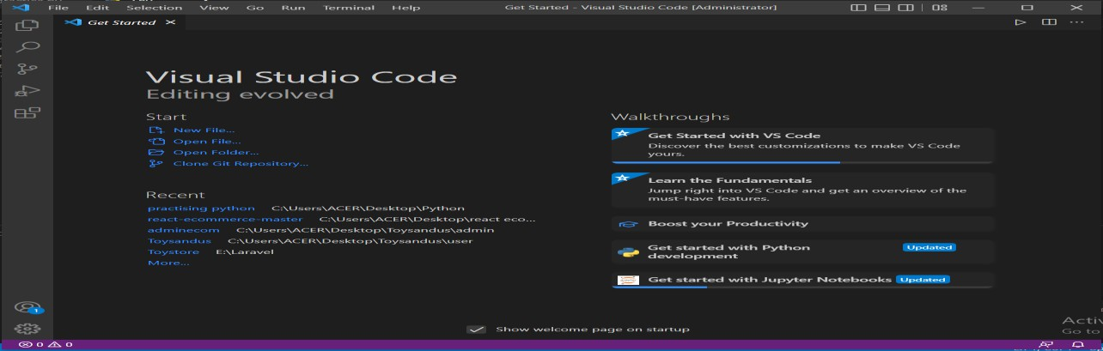With a focus on code editing for a range of development contexts, such as online, mobile, and cloud development, Visual Studio Code is an open source and cross-platform programming tool. Write and debug code fast and effectively with Visual Studio Code on every platform, device, programming language, and operating system of your choosing (Del Sole, 2019).

Figure 1 Visual Studio Code

## Balsamiq Mock-up’s

Balsamiq Mock-up’s is a graphical user interface mock-ups builder application which allows users to arrange pre-built widgets using a drag and drop editor. It comprises of a few basic components which are used while creating the mock-up (Mohite, 2014).

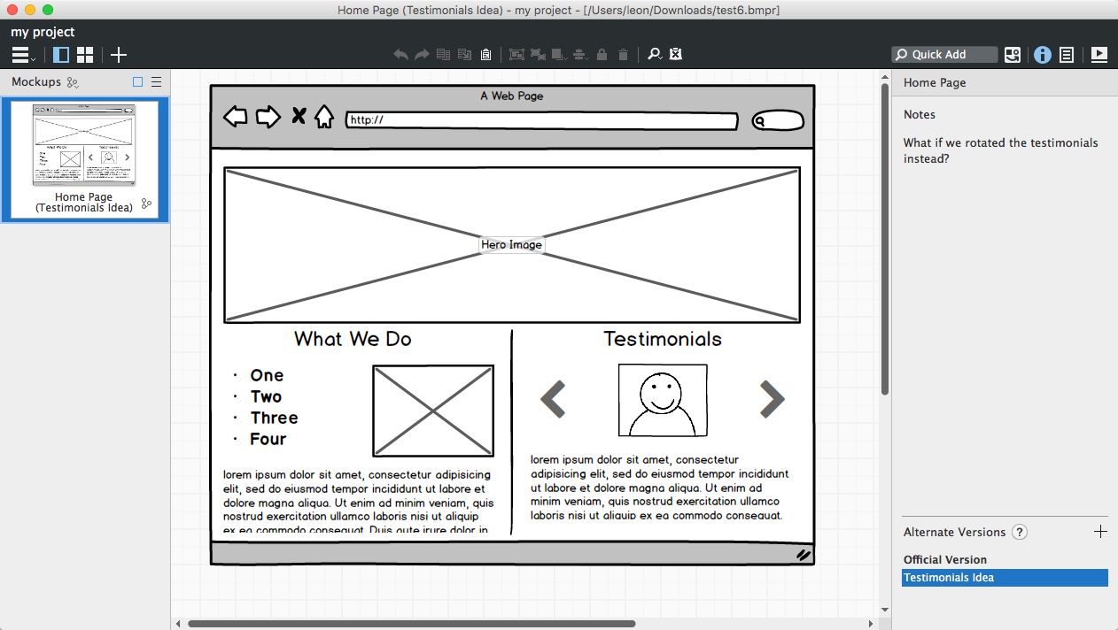

Figure 2 Balsamiq Mock-ups

## HTML

The coding that organizes a web page and its contents is called HTML (Hyper Text Markup Language). Content might be organized, for instance, using data tables and graphics, a list of bulleted points, or a series of paragraphs (Castro, 2003).

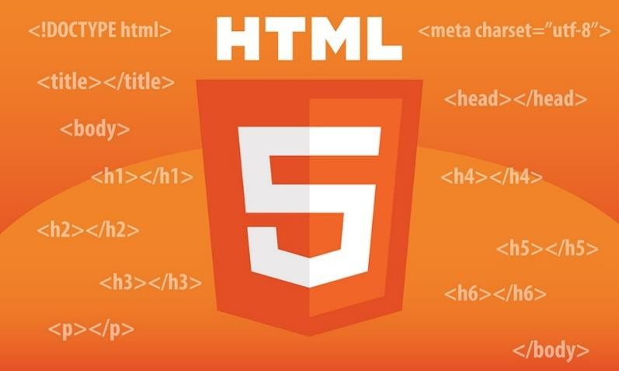

Figure 3 HTML

## CSS

With Cascading Style Sheets (CSS), you may define the presentation and visual style of your online application. You can distinguish between style and structure using CSS. This implies that you are examining less code while interacting with your page. Keeping design distinct from content and organization also makes things easier to manage. A collection of programmable rules called Cascading Style Sheets specify how the material on your web pages is displayed (Grant, 2024).

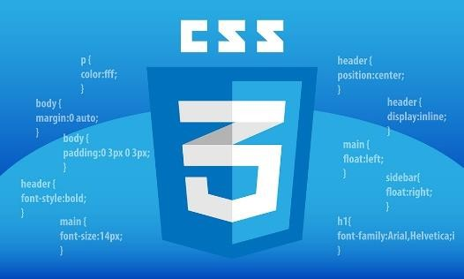

Figure 4 CSS

## JavaScript

JavaScript is the programming language of the Web. JavaScript is a high-level, dynamic, untyped interpreted programming language that is well-suited to object-oriented and functional programming styles. Java Script derives its syntax from Java (Flanagan, 2011).



Figure 5 JavaScript

# Webpages and their wireframes

Wireframes are simple back and white layouts that outline the exact size and placement of your website’s page elements, site features, conversion areas, and navigation.

## Homepage

Any website’s homepage is its default or homepage. To offer the consumer a clear idea of what to expect from the e-commerce site, the homepage of this website provides descriptions of the different latest smartwatches.

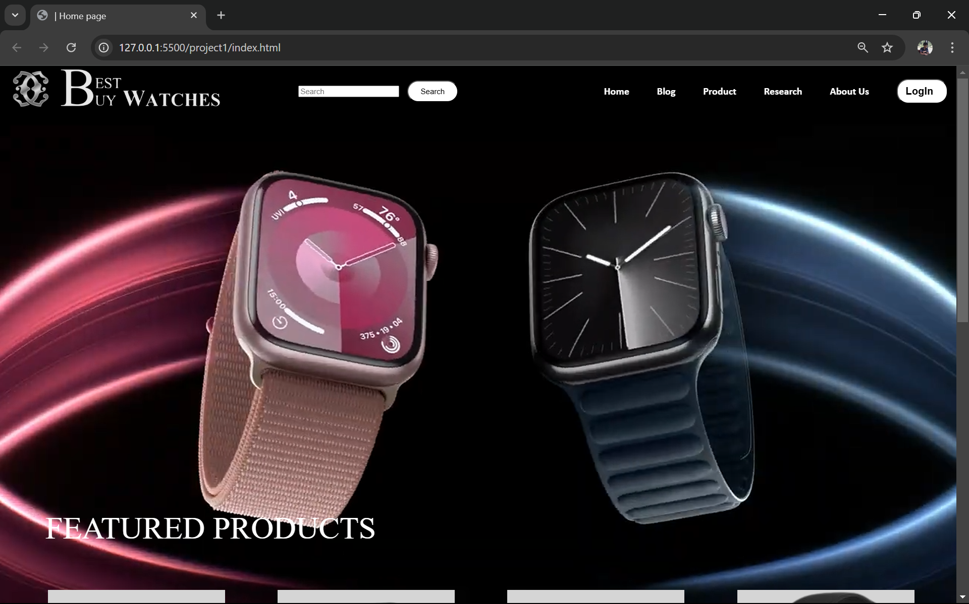

Figure 6 Homepage Web

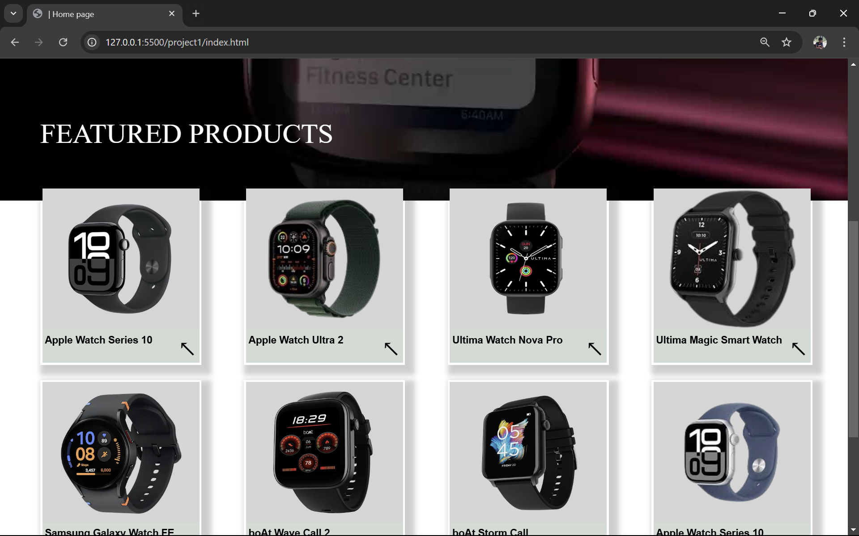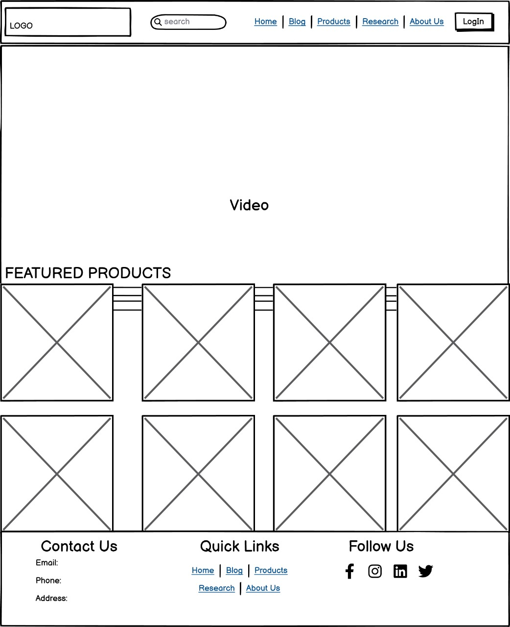

Figure 7 Wireframe Homepage

## Products

We may view a variety of items that are available for purchase on the internet by visiting the product page. After browsing a variety of smartwatches, the customer can click “Explore” button to complete the order.

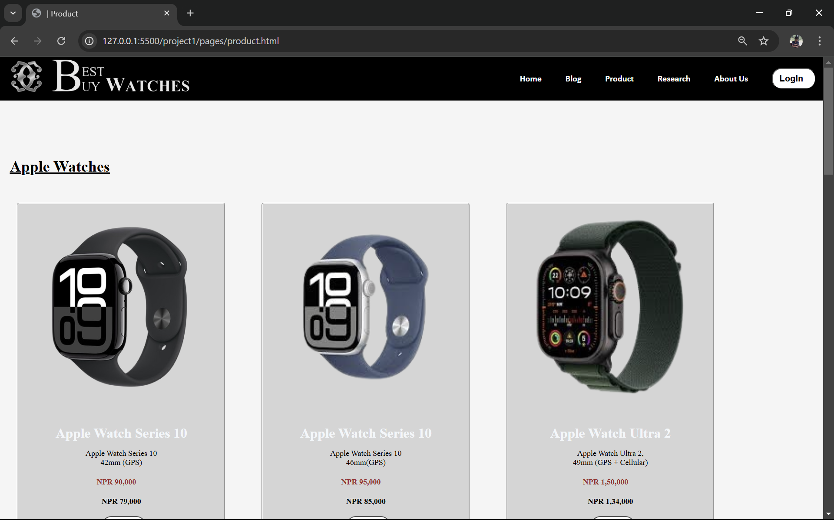 We

Figure 8 Products Web

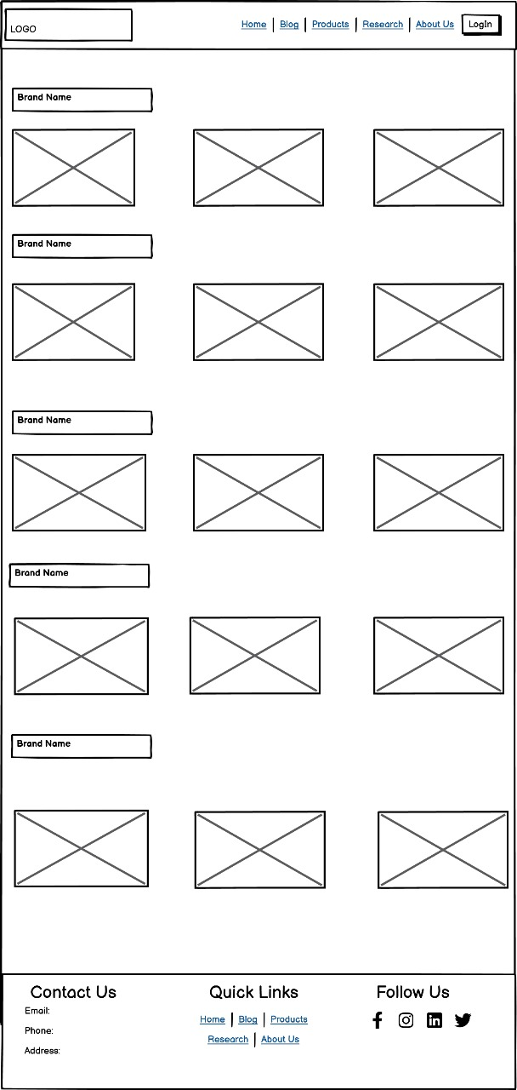

Figure 9 Wireframe Products

## Blog

The blog section provides various information and updates regarding the technology and its evolution, boost of sales, rise of smartwatches and some information regarding the company whose items have been listed.

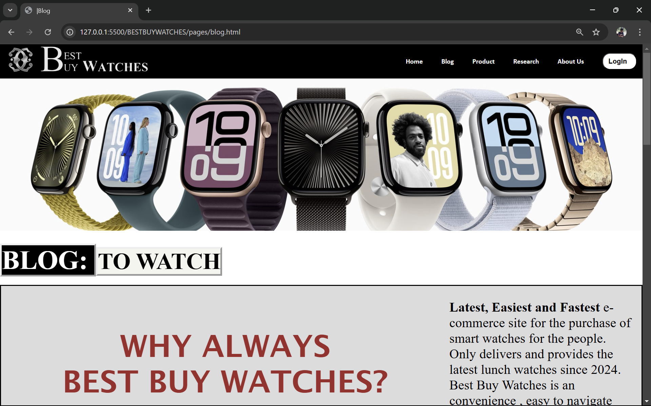

Figure 10 Blog Web

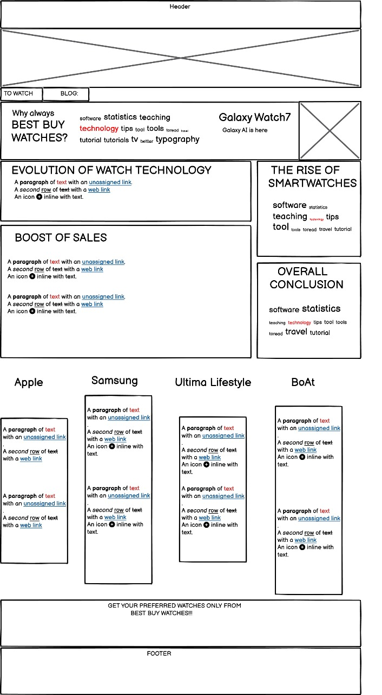

Figure 11 Wireframe Blog

## About Us

In the about us page, the details of all the people who worked to make the project is listed and a feedback form is also provided to the user if they have any questions or any kind of feedback that is to be given to the developers of the website.

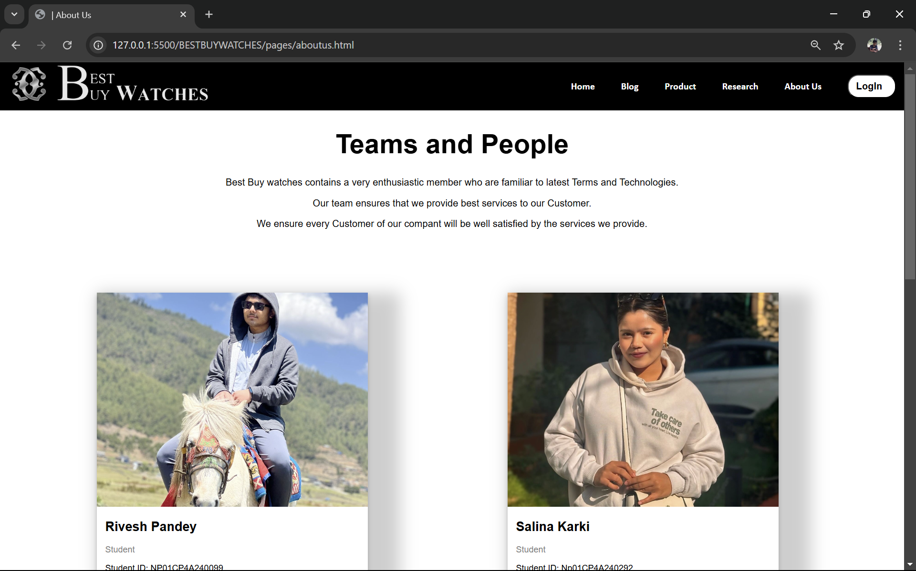

Figure 12 About us Web

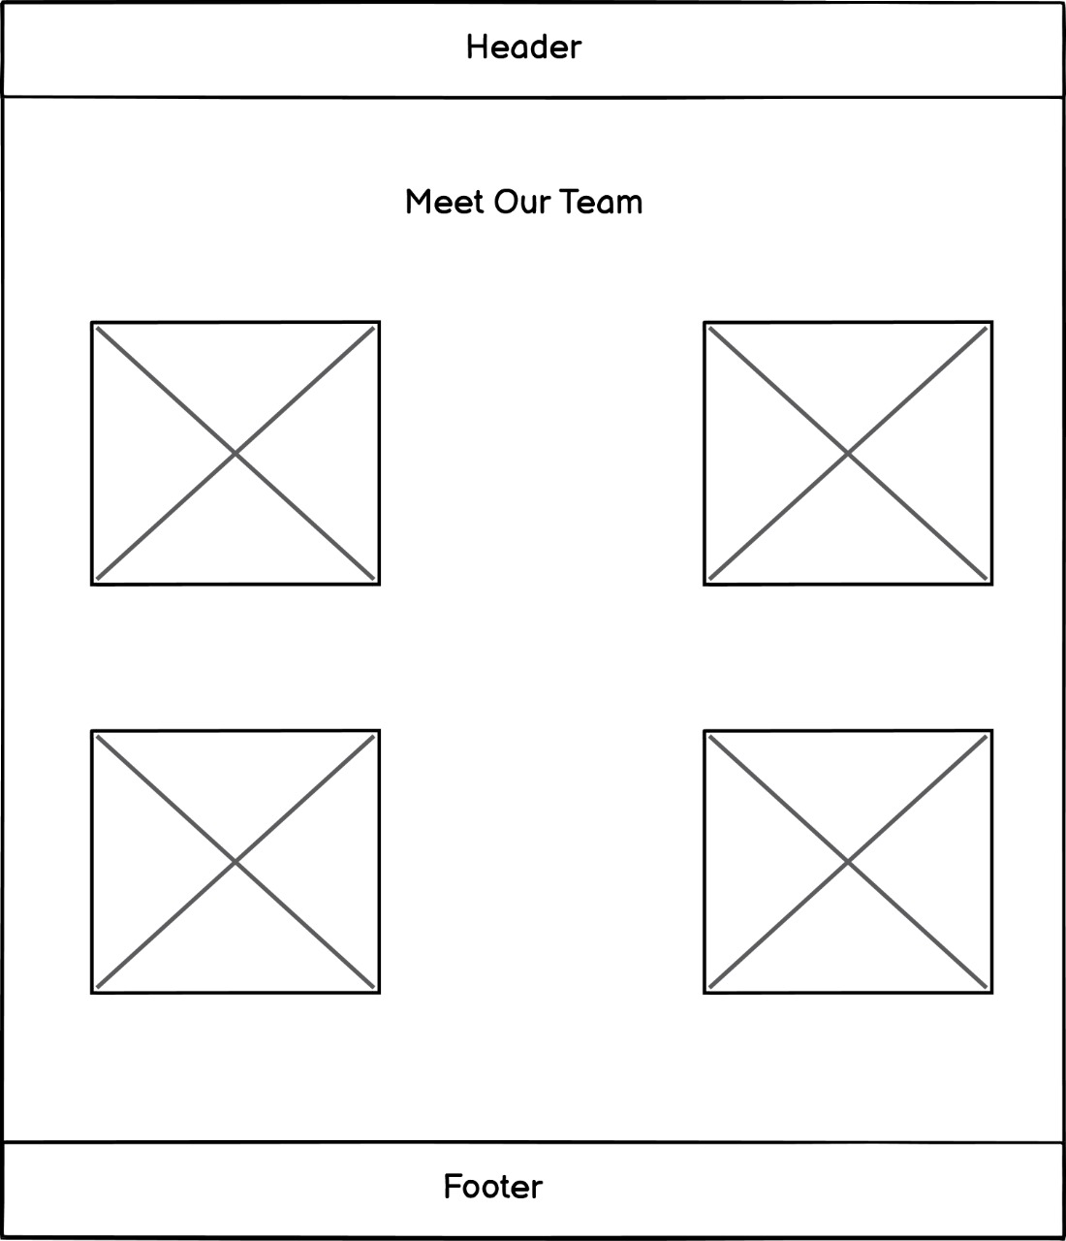

Figure 13 WireFrame About Us

## Research

In the research section, we provide all the information on what we researched and referenced while making the website.

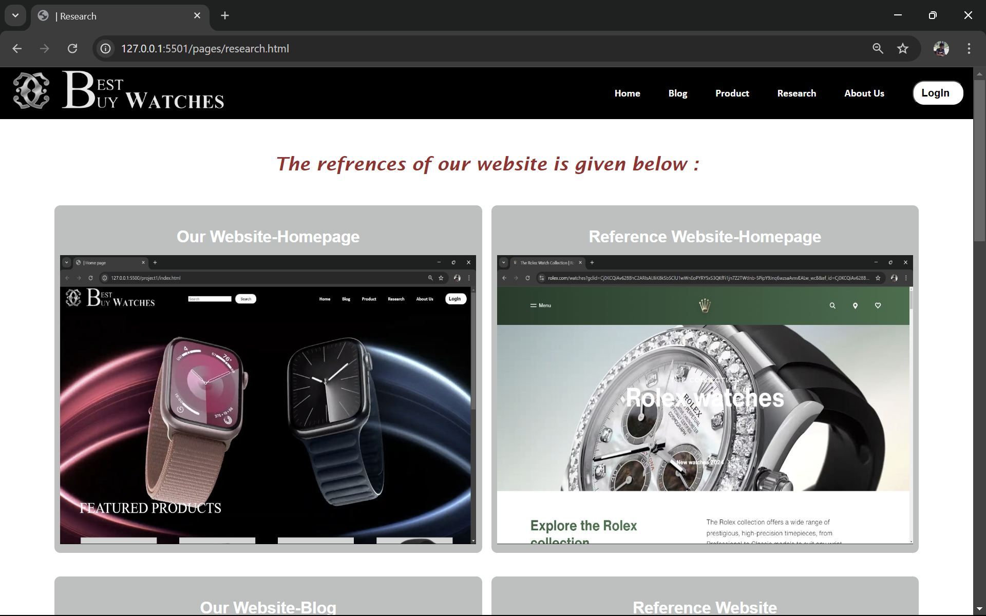

Figure 14 Research Web

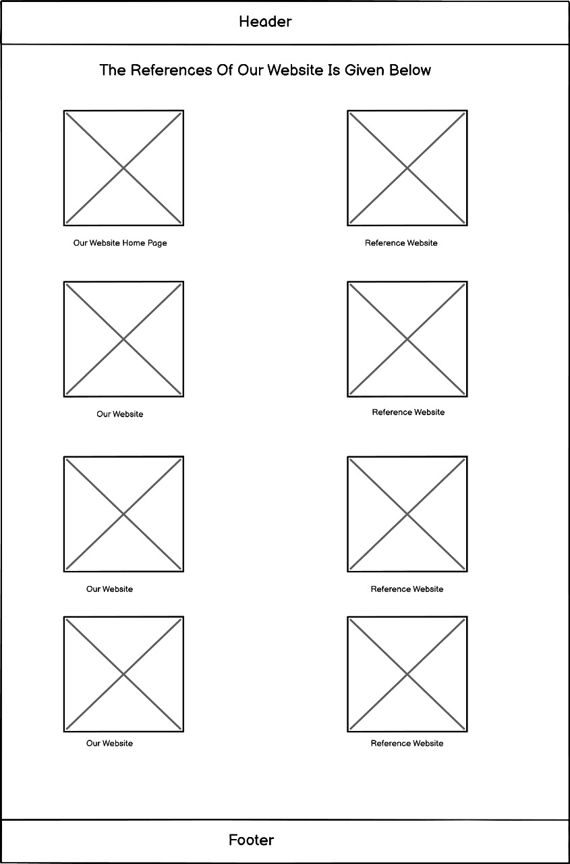

Figure 15 Wireframe Research

## Login

In the login page, users can login their existing account or open a new account if they are new to the webpage for further purchase of listed items on the website.

Figure 16 Login Web

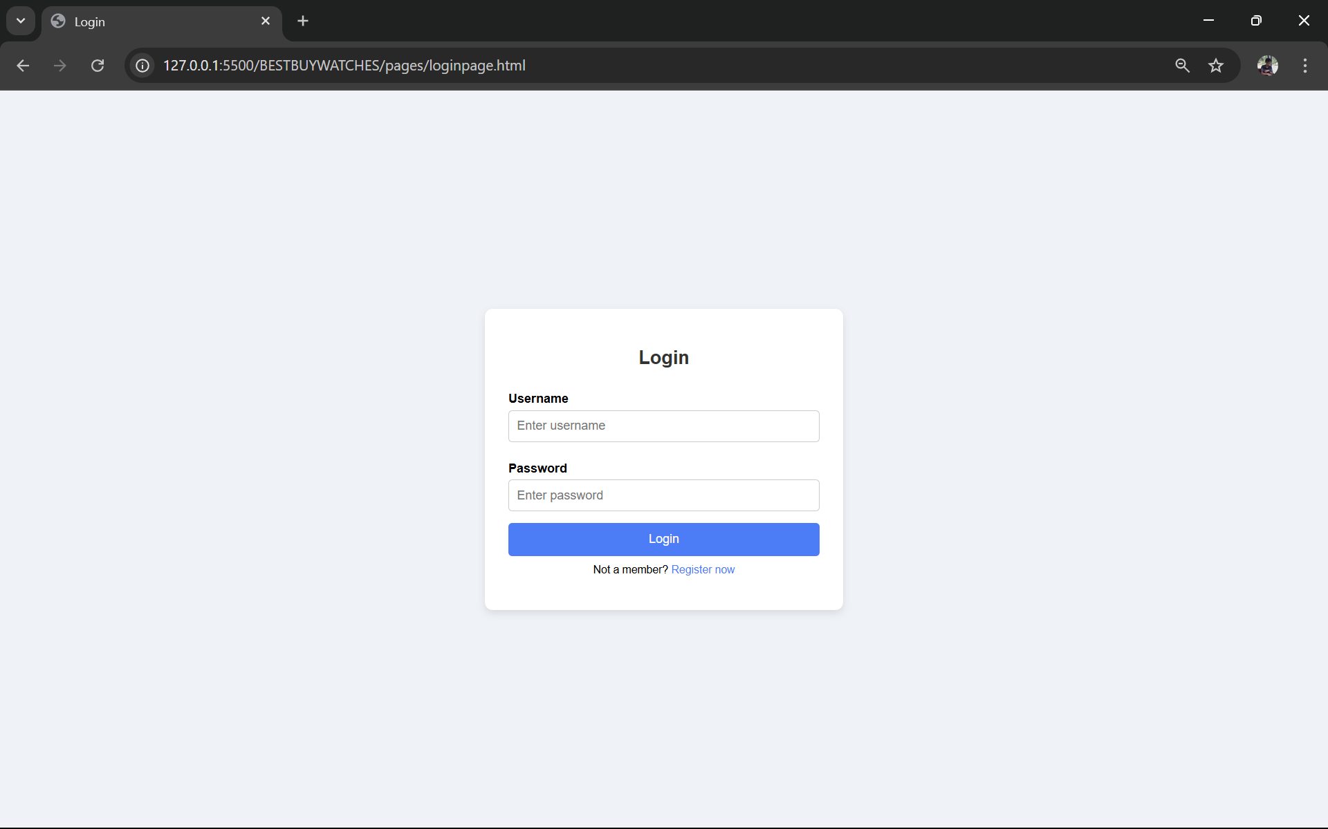

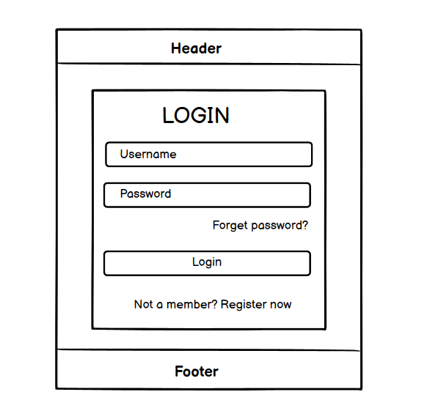

Figure 17 Wireframe Login

# Test Cases

The process of testing a website to see if it works is called testing. A web developer must check that pictures are shown correctly and that HTML elements are functioning correctly before launching a website. In addition, I’m going to make sure my website is still operational. We test the highlighted and important elements in the embraced website.

|  |  |
| --- | --- |
| Objective | To check whether the form is filled completely or not. |
| Action | Both fully and partially completing the form. |
| Expected Result | If the form is filled completely a pop-up appears saying “Successfully logged in”  If the from is not filled completely a pop-up appears saying “Please  completely fill the form”. |
| Actual Test | The correct pop-up appeared. |
| Result | The test was successful. |

## Test 4.1 Form Validation

Table 1 Form Validation

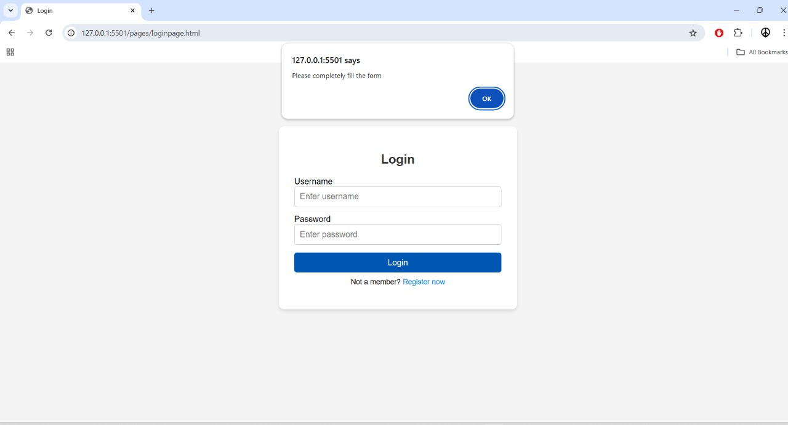

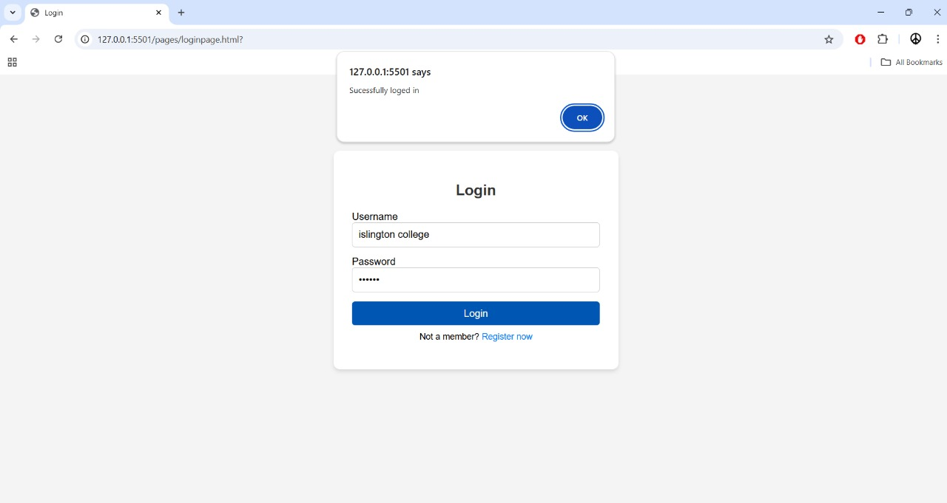

## Test 4.2 Hoover Effect

|  |  |
| --- | --- |
| Objective | To check whether the hover effect is working or not. |
| Action | The hover effect should change according to the cursor moved. |
| Expected Result | When clicked at the one of the options of navbar it should turn orange. |
| Actual Test | Yes, the hover effect worked and turned orange. |
| Result | The test was successful. |

Table 2 Hoover Effect









## Test 4.3: Display message while opening website

|  |  |
| --- | --- |
| Objective | To check if the message is displayed after opening the Homepage of the website. |
| Action | Click the website link |
| Expected Result | The Message “WELCOME TO BEST BUY WATCHES!!”  Should be displayed. |
| Actual Test | Opened the link. |
| Result | The test was successful. |

Table 3 Display message while clicking the website

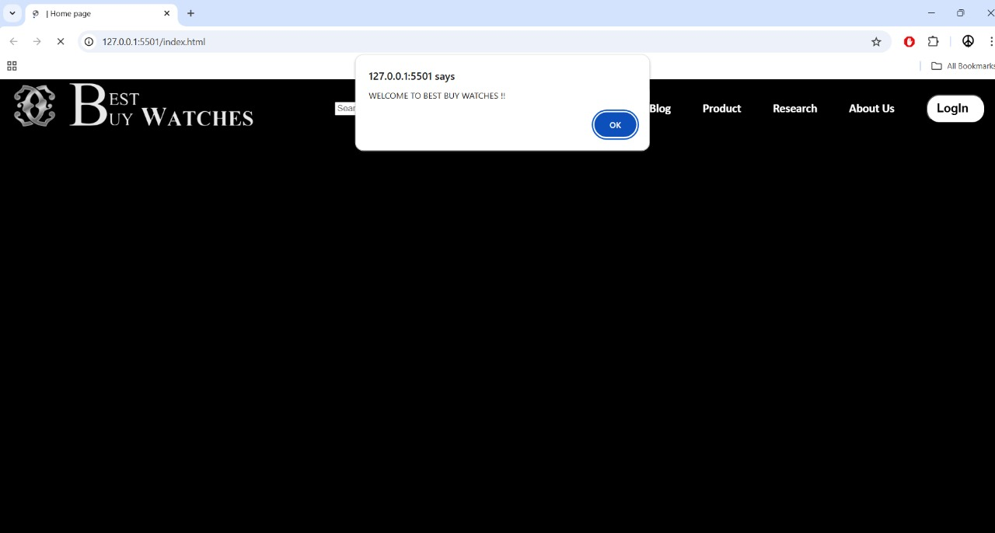

## Test 4.4: External links

Table 4 External Links

|  |  |
| --- | --- |
| Objective | To switch to another webpage using external links. |
| Action | Click the More Information in about us page to view the portfolio. |
| Expected Result | It will redirect to the respective profiles. |
| Actual Test | Opened the page. |
| Result | The test was successful. |

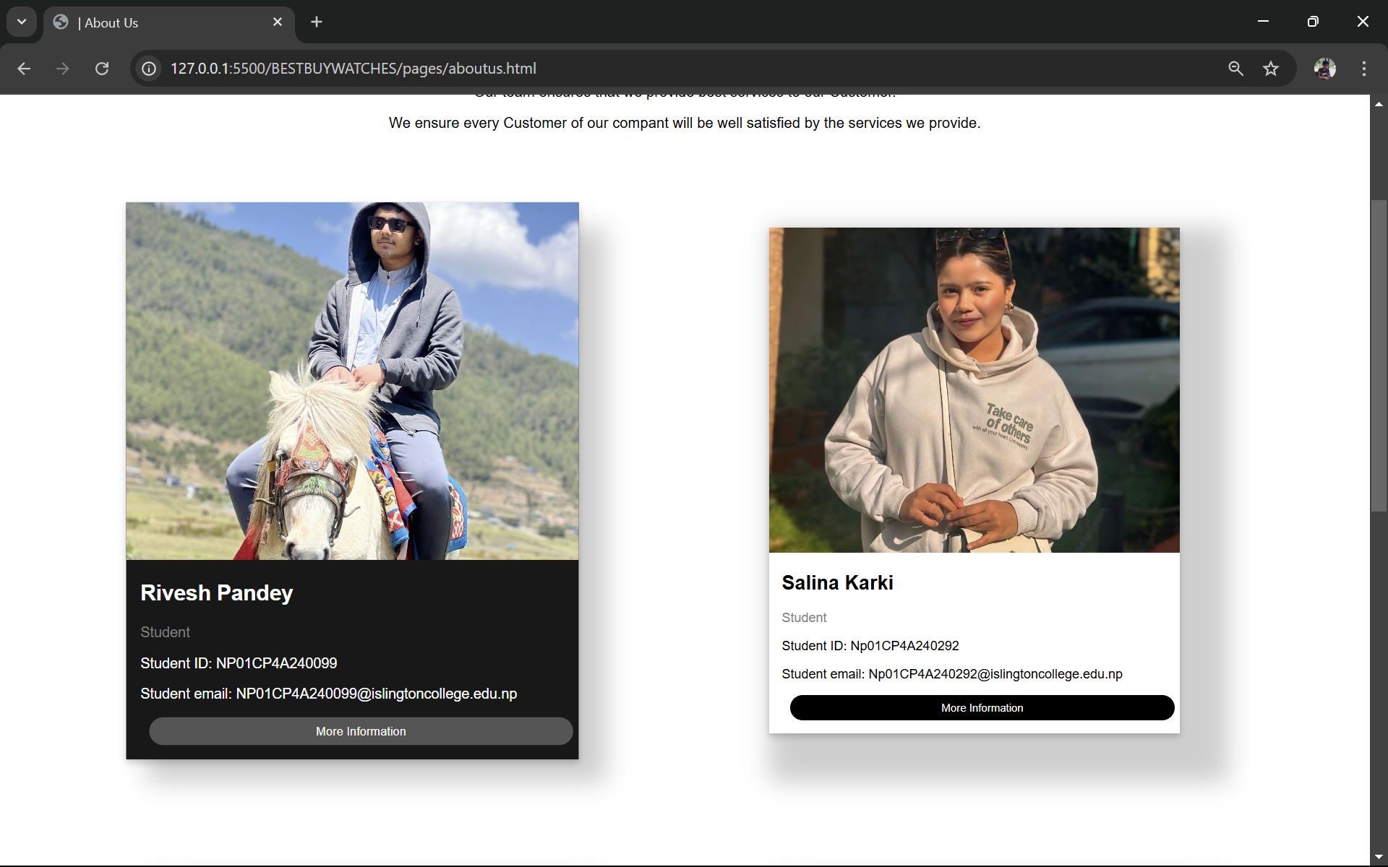

### 

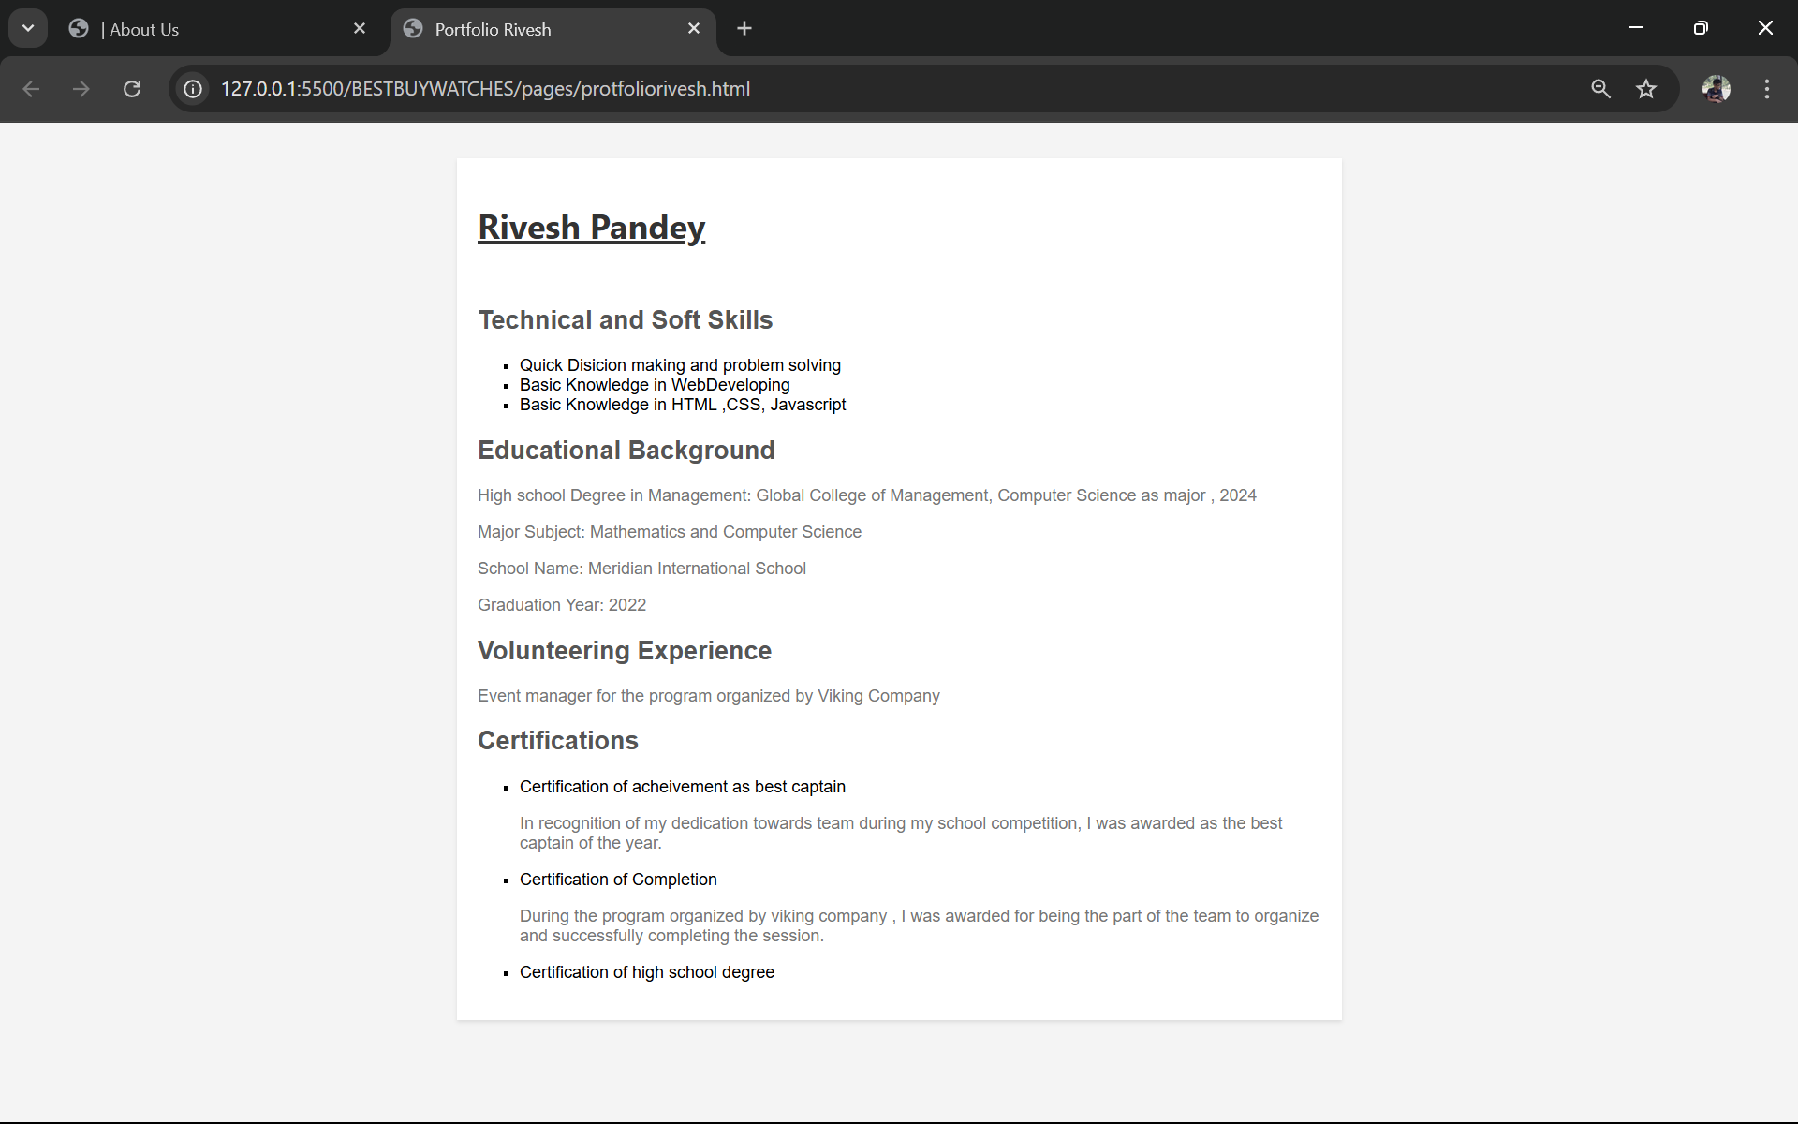

## Test 4.5: Internal Links

|  |  |
| --- | --- |
| Objective | To switch to another webpage using internal links. |
| Action | Click the Official Watch Website icon in blog page to open the  official websites of different companies |
| Expected Result | It will redirect to the respective profiles. |
| Actual Test | Opened the page. |
| Result | The test was successful. |

Table 5 Internal Links

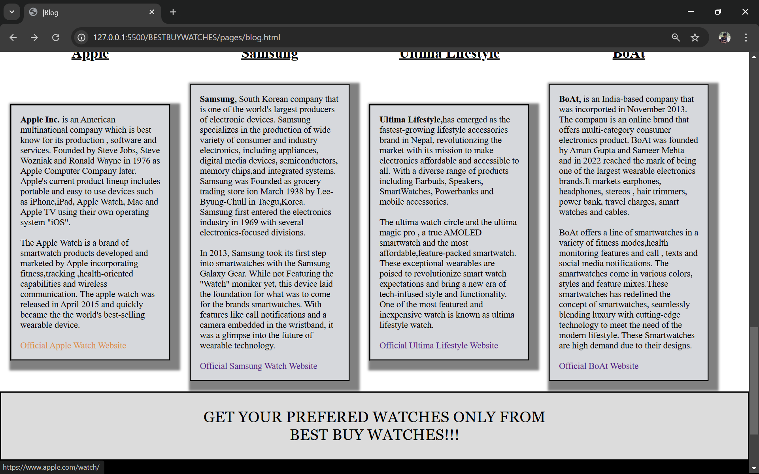

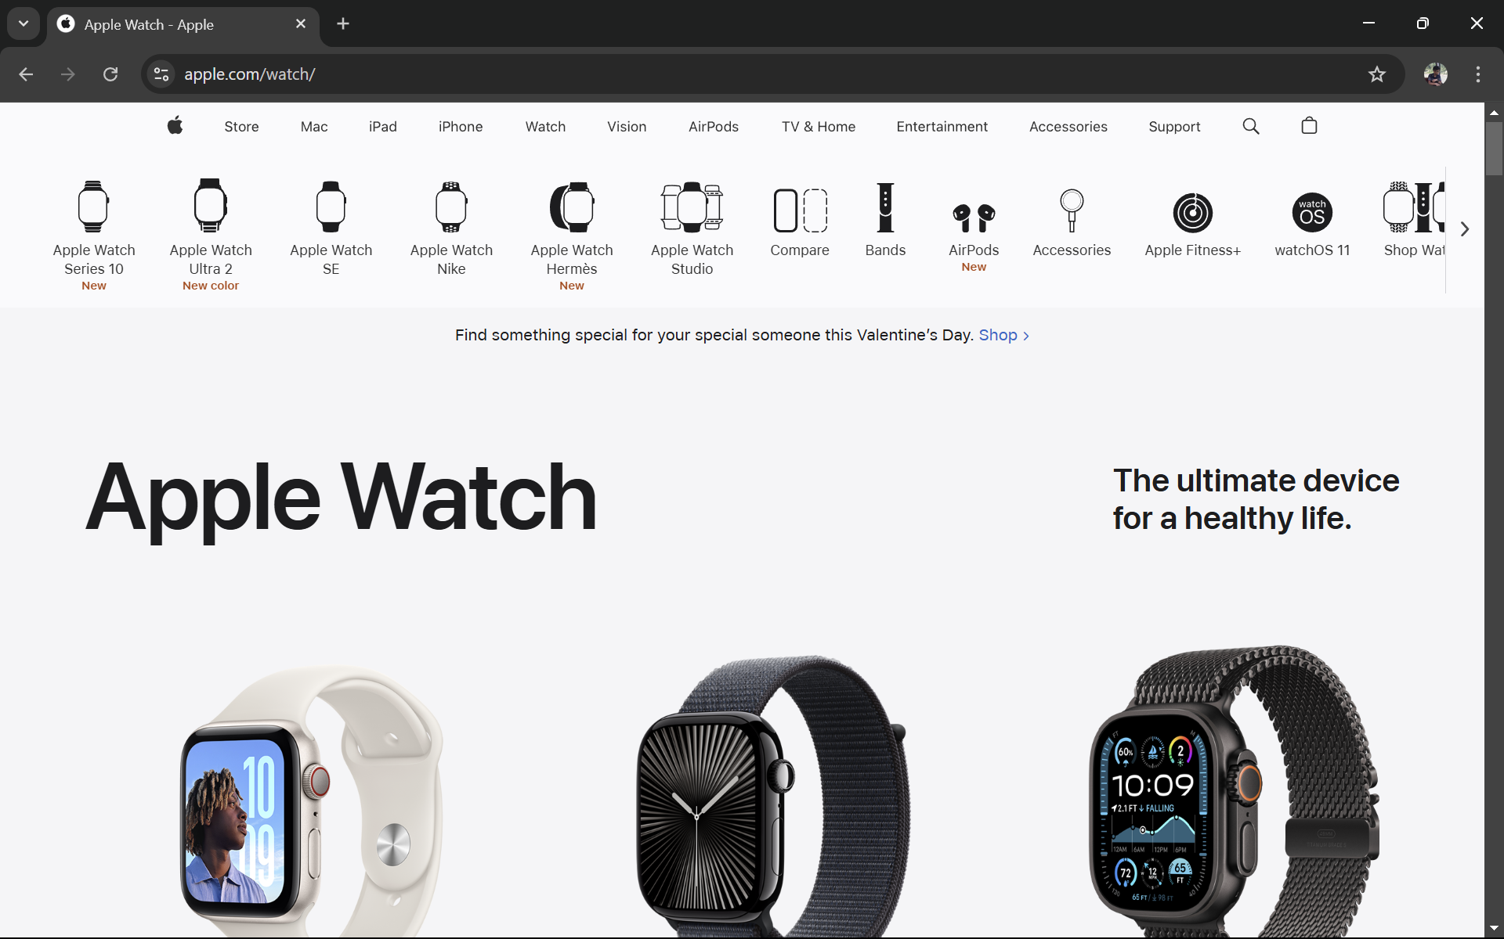

## Test 4.6: Add to Cart

|  |  |
| --- | --- |
| Objective | To display the message after adding it to the cart |
| Action | Select the preferred watch from product page, and click the add to  Cart button. |
| Expected Result | The Message “Added to Cart ”  Should be displayed. |
| Actual Test | Opened the page. |
| Result | The test was successful. |

Table 6 Add to Cart

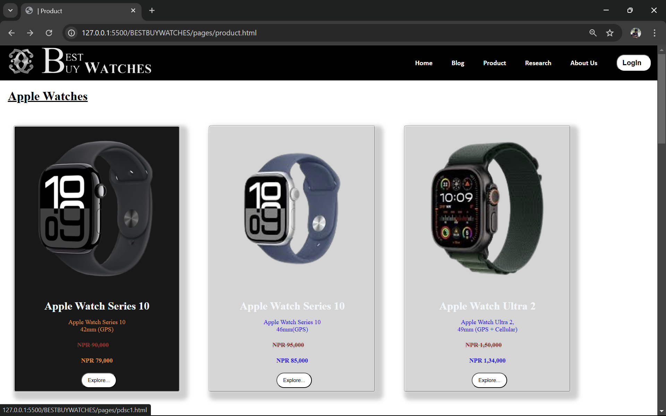

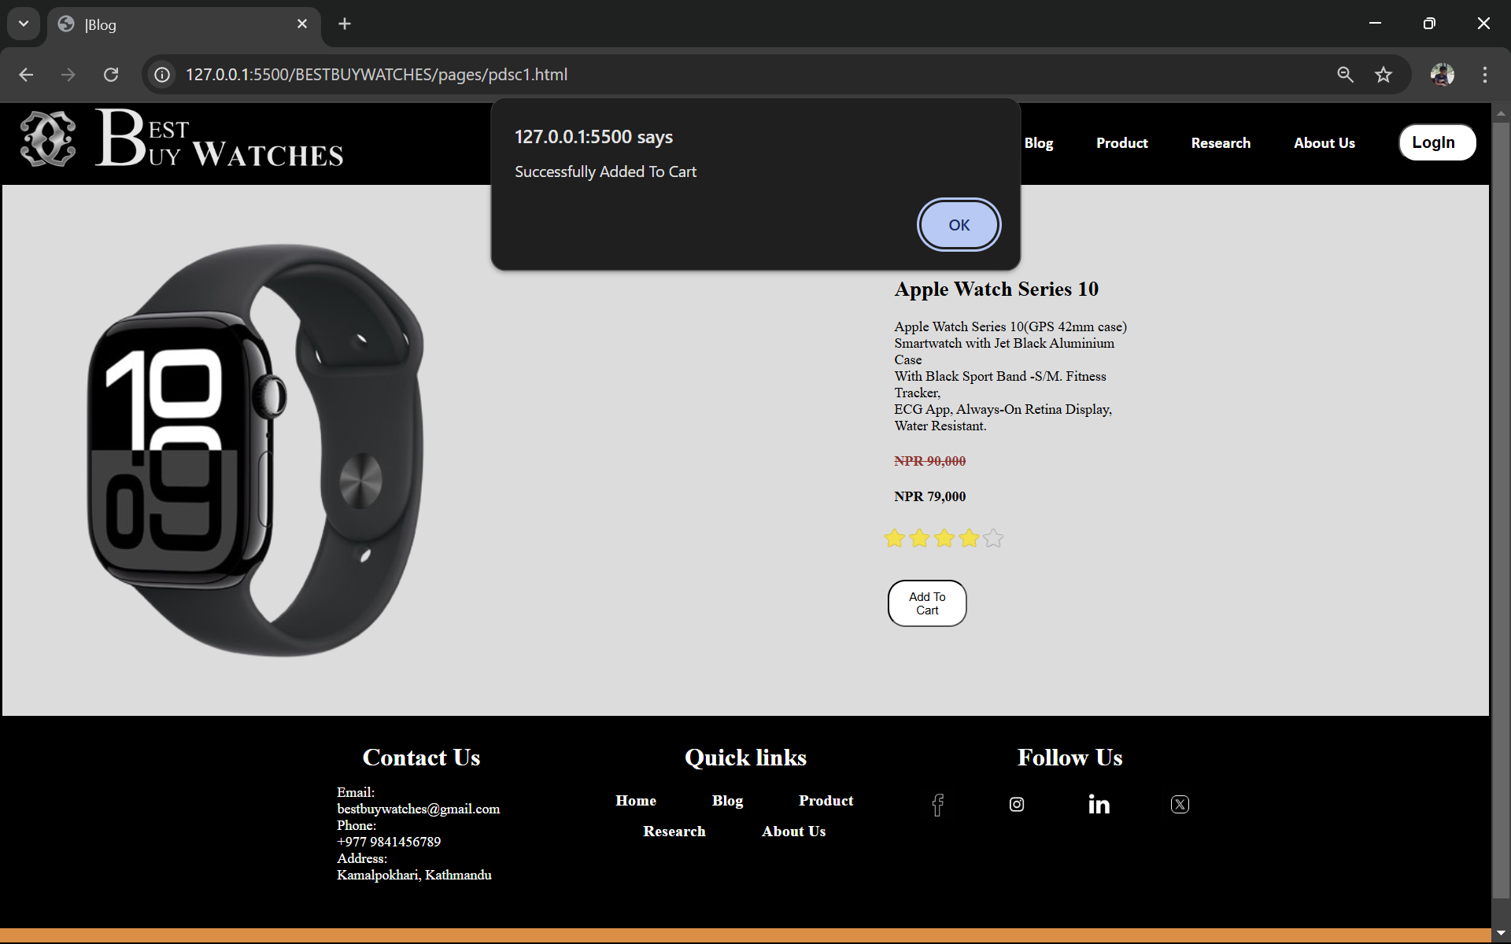

# CONCLUSION

After putting in a lot of effort into the coursework, the team finally completed the coursework in time. We learnt how to collaborate as a team for the first time since starting college because it was group assignment. We studied a variety of languages, including JavaScript, HTML and CSS. The coursework was very hard to start because of our lack of proper knowledge in the programming languages but we eventually completed the project using various resource materials on the internet. Code with Harry was an important YouTube channel that we used as reference to learn the programming languages properly. The courses were well explained and well documented by the owner of the channel.

Being this project as our first project of Islington College, creating an e-commerce website on watch topic was also slightly challenging. Because it was new to the group members to record a project in a group adjusting the project documentation was also a little difficult. Due to various mistakes in the project, the testing phase took a long time. Also, the fact that many of the reference websites lacked authors made the research required to record the project even more difficult. However, the coursework was eventually finished and polished for submission.

# References

Anon., n.d. s.l.:s.n.

Castro, E., 2003. *HTML for the world wide web..* s.l.:Peachpit Press.

Del Sole, A. a. S., 2019. *Visual Studio Code Distilled..* s.l.:Apress..

Flanagan, D., 2011. *JavaScript: The definitive guide: Activate your web pages..* s.l.: O'Reilly Media, Inc.

Grant, K. 2., 2024. *CSS in Depth.* Simon and Schuster: s.n.

Mohite, N. a. H. P., 2014. *Mockup To Web Page Conversion..* 3 ed. s.l.:International Journal of Engineering Research, .